647 Old Garden River Rd Sault Ste. Marie, ON P6A 0C9 705-253-7871 ssmhpc@gmail.com

MEMBERSHIP FORM (Please Print)
Membership Year: SEPTEMBER 1, 2022 to: AUGUST 31, 2023
Name: Home Phone: Email: ** Cell Phone: Preferred Contact: Home or Cell (please circle one)
Mailing Address:
Highest Canadian Pony Club Riding Test or OEF Rider Level:
Type of Membership and Annual Fee
- Individual Riding Membership $35.00

- Family Membership
$50.00

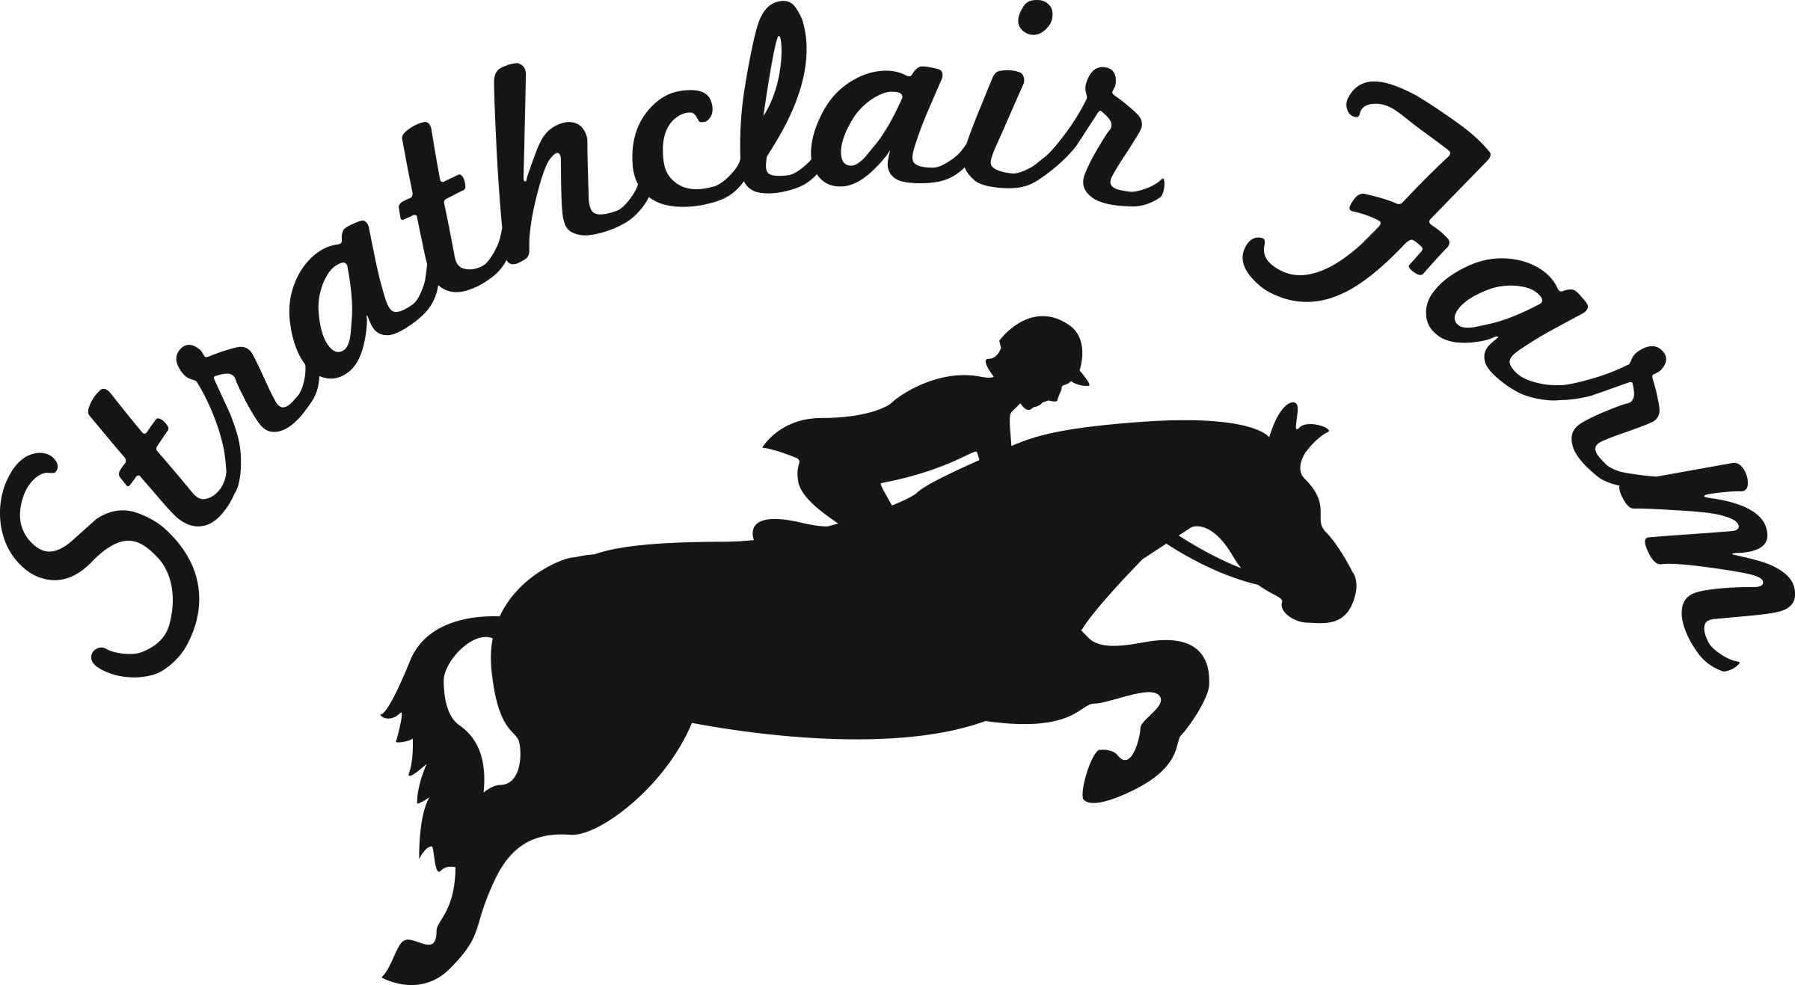
- Non‐Riding Membership $20.00

If Under 18: Rider’s Age: Date of Birth:
- Parent or Guardian: Home Phone: Cell Phone: Work Phone: Preferred Contact: Home, Business or Cell Email:
- Parent or Guardian: Home Phone:
Cell Phone: Work Phone: Preferred Contact: Home, Business or Cell
- Alternate Emergency Contact: Relationship: Phone:

**For Riding Lesson Students:
Lesson Program and associated information will be provided on an on‐going basis and will be communicated via email to all members and will also be posted on the bulletin boards.
Comments, issues or general inquiries can be addressed by speaking to your instructor or by sending an email to ssmhpc@gmail.com
If participating in riding lessons, follow all directions of the instructor at all times and arrive at least 30 minutes before the lesson and stay 30 minutes after the lesson to ensure proper care and grooming of assigned horse.

Photo and Video Consent:
By signing below you are consenting to the taking of photographs and/or video recordings of the above mentioned rider by SSMHPC. You are assigning to SSMHPC, and waiving any rights you have related to, any such photographs and/or video recordings, and you are consenting to the use of any such photographs and/or video recordings in whole or part, by SSMHPC.
I have read and understand the Photo and Video Consent:
Signature: Date:

Code of Conduct Consent:
The safety of each individual in our lesson program is of the utmost importance to SSMHPC. Each lesson student must take responsibility to learn and follow at all times, all rules of the farm and direction of SSMHPC staff. I understand that any behaviour of my child that places him/herself or others at risk may result in immediate dismissal from that day’s lesson with no credit or refund. Further participation in the lesson program will only continue with the consent of the Head Coach upon consultation with staff and parent/ guardian.
I have read and understand the Code of Conduct Consent:
Signature: Date:

THIS AGREEMENT MUST BE COMPLETED IN FULL, SIGNED, DATED AND WITNESSED BEFORE ANY ACTIVITY WITH HORSES MAY BE UNDERTAKEN
- I understand that failure to abide by the Club Rules and Code of Conduct can result in immediate revocation of my membership and denial of access to the property
(initial)
- I will wear a helmet at all times while mounted or mounting a horse (initial)
- I will wear proper riding footwear with a heel while riding and closed‐toed shoes while on the property (no sandals or flip flops) (initial)
Further:
I realize the Club’s membership is from September 1 to August 31. I understand that infractions of rules can result in suspension and/or exclusion from the club. I hereby release Strathclair Farm (a.k.a. The Sault Horse and Pony Club Inc.) and its Club officials, volunteers, directors, agents, representatives, servants, employees and the City of Sault Ste. Marie from all liability whatsoever while myself, my horse(s) and/or my property is on the Strathclair Farm site assigned to the Club, and any consequences of my participation in activities there on or in connection with activities at the Club, including the use of approved Club hacking trail, lessons, schooling and horse shows, clinics and camps. I realize that recreational horseback riding can be unpredictable and potential dangerous and I do so at my own risk.

Signature of Member: Date:

Signature of Parent/Guardian: Date:

Signature of Parent/Guardian: Date:

For Office Use Only:
Signature of Club Representative reviewing Membership form with Member:
Signature of Board Member Processing Application: Date:

